 |  |  | INFORMATION REGARDING SCHOOL
1. | Name of the school with address: |  | Sacred Heart Public School Kilimala
 | (strictly as per Affiliation sanction |  | Thrickodithanam P.O Changanacherry
 | letter or as permitted by the |  | Kottayam Dt 686105
 | Board) with pin code no.
 | (i) | E-mail | principal@shps-kili.org
 | (ii) | Ph..No. | 0481- 2447634, 2446734
 | (iii) Fax No. |  | Nil
2. | Year of establishment of school |  | 1996

- Whether NOC from State/UT

or recommendation of Embassy

of India obtained? |  | NOC from State
(i) | NOC No. | 51415 | N3 | 99 | G.Edn
(ii) | NOC issuing date | 17 | 9 |1999
4. Is the school is recognized, if yes
by which authority |  | CBSE

- Status of affiliation:

Permanent/ Regular/ Provisional

(i) | Affiliation No. | 930341
(ii) | Affiliation with the Board since | 2001
(iii) Extension of affiliation up to |  | 2017
6. Name of Trust/Society/Company |  | Archdiocesan Educational and
Registered under Section 25 of |  | Charitable Trust
the company Act, 1956.
Period up to which registration of
Trust/Society is valid |  | Unlimited

7. List of members of school |  |  | FR. JAMES PALACKAL, FR.PHILIPS WADAKKEKALAM, FR. SHIJU SEBASTIAN, | FR.CYRIL CHEPPILA
Managing Committee with their |  |  | FR. PHILIP THAYIL, SR. VIMALA, FR.TOMY PADINJARE VEETTIL, | DR.V.T.ANTONY
Address/tenure and post held |  |  | PROF. N.J JOSEPH, PROF. BABY JOSEPH, MRS. SEEPHA JOE | REJAY THOMAS, MRS JOYAMMA
8. Name of official address of the |  |  | Rev. DR. JAMES PALACKAL,
Manager/President/Chairman/ |  |  | S.H Public School and Jr. College
Correspondent |  |  | Thrickodithanam P.O, Chry
(i) | E-mail
(ii) | Ph..No. |  | 9048363040
(iii) Fax No. |  |  | Nil
9. Area of school campus
(i) | In Acres |  | 4
(ii) | In sq. mtrs. |  | 16187. 4256
(iii) Built up area (sq. mtrs) |  |  | 1239.2
(iv) Area of playground in sq. mtrs |  |  | 8565
(v) | Other facilities
 | (i) | Swimming Pool | Nil
 | (ii) | Indoor Games | Yes
 | (iii) | Dance Rooms | Yes
 | (iv) | Gymnasium | Nil
 | (v) | Music Rooms | Yes
 | (vi) | Hostels | Yes
 | (vii) | Health and Medical
 |  | Check up | Yes

- Details of fee structure

  - Pre - Nursery

  - Nursery

 | (iv) I to IV | 680
 | (v) V to VII | 798
 | (vi) VIII & X | 854
 | (v) XI & XII | 1638
11. Transport Facility
(i) | Own Buses | Own Buses
(ii) | Buses hired on contract basis | Nil

13. Details of salary being paid by the school to teaching Staff/non -teaching staff(to be updated time to time) as per circular No.07/2013 dated 1-5-2013

Designation | Scale of
PGT/TGT/PRT/Counsellor/etc. | pay | ESI and EPF given
PGT | 20,000 | as per Govt. Rule
TGT | 15,000
PRT | 10,000
Clerk | 8,000
IV Class | 6500

- Mode of payment of salary

(i) | Name of the bank through which salary is drawing | C.S.B Nalukody
(ii) | Through single cheque transfer advice | Single Cheque
(iii) | Individual cheque | Nil
(iv) | Cash | Nil

- Library facilities

 | (i) | Size of the library in sq.feet | 1864 sq.
 | (ii) | No. of Periodicals | 26
 | (iii) | No. of Dailies | 6
 | (iv) | No.of Reference books class-wise | 1373
 | (v) | No.of Magazine | 10
 | (vi) | Others | 7564
16. | Name of the Grievance/redressal Officer |  | Fr. Shiju Sebastian, Principal
 | with e-mail, Ph.No., Fax No. |  | fr.shijusebastian@gmail.com
17. | Members of Sexual Harassment Committee |  | Rev.Dr. James Palackal, Fr. George Joseph
 |  |  | Mr. Mathew T, Mr. Alex, Mr. Jijo P.E.T
 |  |  | Mrs. Sindhu George, Mrs. Anu Johnson
18. | Section wise enrollment of school for the current session |  | Class | section | Enrolment
 |  |  | Class 1 | A | 40
 |  |  |  | B | 40
 |  |  |  | C | 40

Class 2 | A | 39
 | B | 39
 | C | 40
Class 3 | A | 39
 | B | 39
 | C | 39
Class 4 | A | 40
 | B | 40
 | C | 39
Class 5 | A | 40
 | B | 40
 | C | 40
Class 6 | A | 40
 | B | 40
 | C | 40
Class 7 | A | 40
 | B | 38
 | C | 40
Class 8 | A | 40
 | B | 40
 | C | 39
Class 9 | A | 40
 | B | 40
 | C | 40
Class 10 | A | 35
 | B | 38
 | C | 35
Class 11 | A | 45
 | B | 40
 | C | 21
Class 12 | A | 38
 | B | 32
 | C | 22

19. | Academic session period |  |  |  |  |  | From Ist June to 31st March
20. | Vacation period |  |  |  |  |  | From Ist April to 28th May
21. | Admission period |  |  |  |  |  | From Ist January to 31st March
Sl.No |  | Section |  | Name & DOB |  | Qualification |  | Professional | Experience in CBSE |  | Other Relevant
 |  |  |  |  |  |  |  | BEd/TTC | Recognized School |  | Information
1. |  | Principal |  |  |  | MA.Med |  | MED | 7½ years of administrative |  | Attended various inservice
 |  |  |  |  |  |  |  | Social Science | Experience and 6 years of |  | Programmes
 |  |  |  |  |  |  |  |  | Teaching experience |  | Examiner, Xth
 |  |  | FR. SHIJU SEBASTIAN
 |  |  | 11-05-1978
2. |  | PGT |  |  |  | MSc Maths |  | MEd Maths | 12 Years |  | Paper Valuation in XII
 |  |  |  |  |  |  |  |  |  |  | 4 years
 |  |  |  | REENI JOSEPH
 |  |  | 22-03-1978
3. |  | PGT |  |  |  | MSc, BEd |  | B.Ed | 5 years |  | Examiner XII
 |  |  |  |  |  |  |  | PGDCA in
 |  |  |  |  |  |  |  | Global
 |  |  | TRONY VARGHESE
 |  |  | 04-11-1978
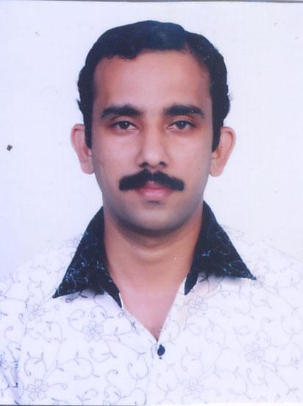
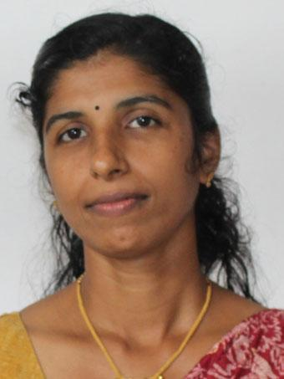
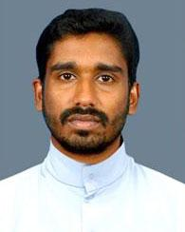

4. | PGT |  | M.C.A | - | 10 years | Invigilator class XIIth

JUBIE JOSEPH 27-12-1979

5. | PGT |  | MA | BEd | 4 Years | -
 |  |  |  |  |  | Examiner class XII

MEJO TESS VARGHESE 10-12-1982
PGT
BEd
10 Years
MSc
6

RITTY JOSEPH
26.09.1980

7. | PGT |  | M.Com | B.Ed | 5 years
 |  |  |  |  |  |  | Examiner of class XII
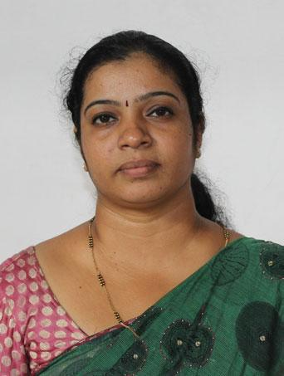
SINDHU GEORGE 12-12-1976

8. | PGT |  | M.Sc,B.Ed | B.Ed | 7 Years | Valuation co-ordinator in XII,
 |  |  |  |  |  | Practical Examiner in XII
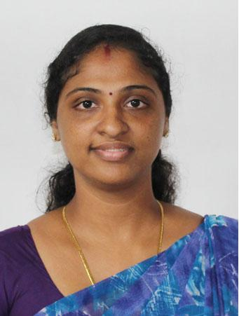
 |  | SONIA SOBHA KURUVILLA
 |  | 24-03-1984
9. | PGT |  |  | M.Sc B.Ed | B.Ed | 8 years | Examiner of class
 |  |  |  |  |  |  | XII (3 years)
 |  |  |  |  |  |  | SET passed
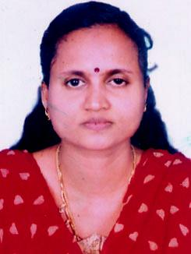
LINCY JOSEPH 10-02-1981

10. | PGT |  | M.Sc B.Ed | B.Ed | 25 years | Examiner -Paper Valuation
 |  |  |  |  |  | in Xth
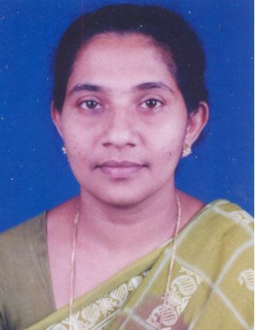
SHERLY THOMAS 05-05-1961

11. | PGT |  | M.A,B.Ed | B.Ed | 15 Years | Examiner XIIth
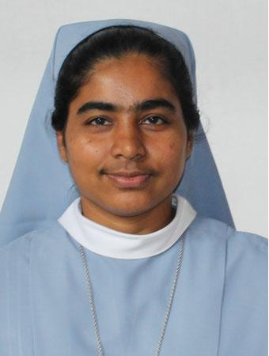
 |  | SR.VIMALA
 |  | 31-03-1975
12. | TGT | M.Sc | M.Ed | 4 years  Examiner Xth
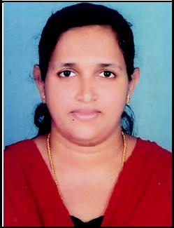

TESSYMOL BINSON 04-03-1979

13. | TGT |  | M.Sc | B.Ed | 4 years | SET, Examiner Class
 |  |  |  |  |  | XII th
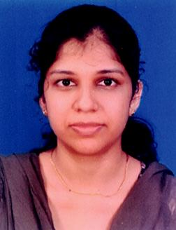
 |  | JISHA GEORGE
 |  | 17-05-1983
14. | TGT |  | ADIT, | 8 Years | Doing M.Com
 |  |  | MA.Sociology |  | (Kerala University)
 |  |  | Diploma in
 |  |  | Journalism
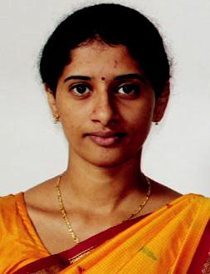
 |  | ANU JOHNSON
 |  | 28-05-1983
15. | TGT |  | M.A B.Ed | B.Ed | 10 years | Examiner X
 |  |  |  |  |  | Paper Valuation
FR. GEORGE 25-01-1973

16. | TGT |  | M.A (Eco) | B.Ed | 2 years | Invigilation Duty
 |  |  |  |  |  | CBSE X th Exam
 |  |  |  |  |  | 1 years Exp.
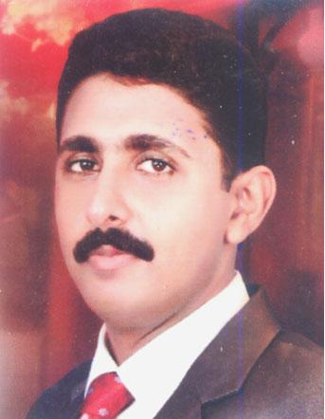
Jeena Alex
15.11.1976

17. | LIBRARIAN |  | B.A, PGDCA | 11 Years
 |  |  | BLISC
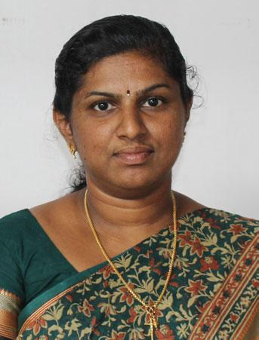
 |  | SIMI MATHEW
 |  | 04-05-1979
18. | TGT |  | M.Sc B.Ed | B.Ed | 10 years | K Tet,
 |  |  |  |  |  | M.Sc IN Psychology,
 |  |  |  |  |  | P.G Diploma in Eng.
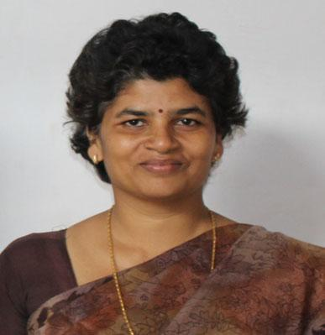
LIGI REJOY 08-05-1972

19. | TGT |  | B.Sc | B.Ed | 14 years
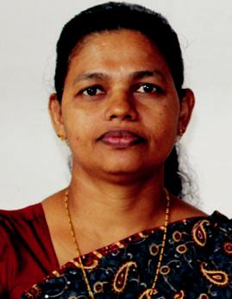
 |  | JOYAMMA JOSEPH
 |  | 31-08-1966
20. | TGT |  |  | M.A, B.Ed | B.Ed | 12 Years | SET,
 |  |  |  |  |  |  | 10th class Examiner-
 |  |  |  |  |  |  | 2 years
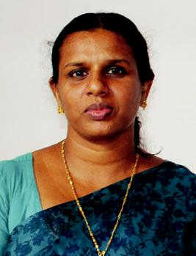
 |  | SONIA MICHAEL
 |  | 31-05-1974
21. | TGT | MSc | B.Ed | 4 years

JINCYJOSEPH
18.10.1981

22. | TGT |  | B.A B.Ed | 13 years | 8 Years Experience in
 |  |  |  |  | the exam paper valuation
 |  |  |  |  | Xth class
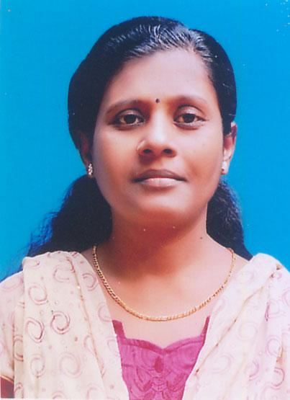
INDU THOMAS 03-02-1971

23. | TGT |  | M.Sc, | B.Ed | 2 YEARS
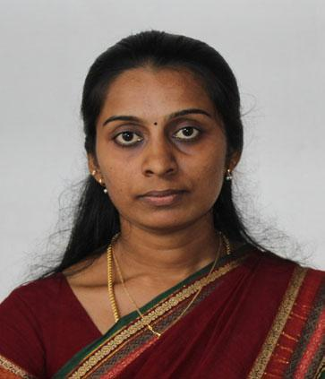
 |  | JAISHA BRIGIT
 |  | 18.08.1982
24. | TGT |  | M.A B.Ed | B.Ed | 10 years | 10th Exam
 |  |  |  |  |  | Supervision
 |  |  |  |  |  | 2 years
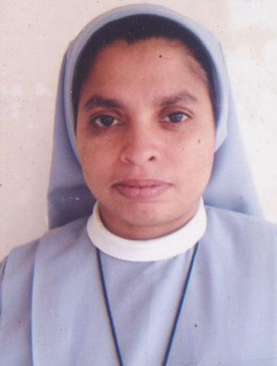
SR. ELSAMMA SDP 21-011-1965

25. | PRT |  | M.A B.Ed | B.Ed | 13 years
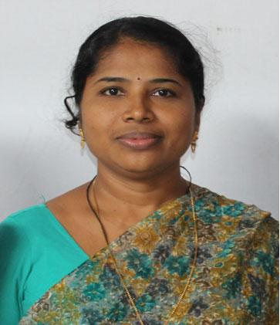
ROY THOMAS 10-03-1977

26. | PRT |  | M.A, B.Ed | B.Ed | 2 Years
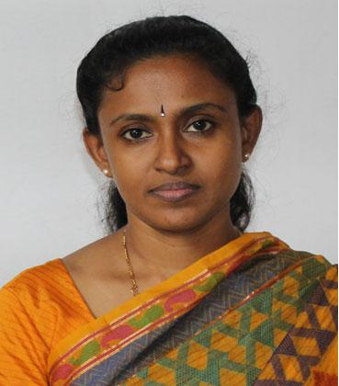
 |  | SOLLY JOSEPH
 |  | 01-02-1972
27. | PRT | B.Sc B.Ed | B.Ed | 13 years
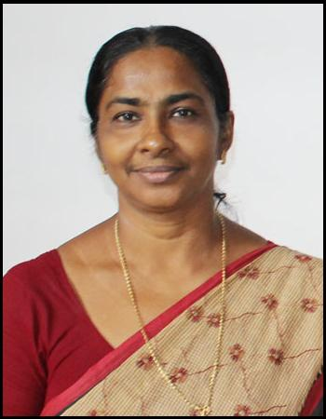

ALEYAMMA JOSEPH 12-05-1964

28. | TGT |  | B.A B.ph | PGDCA | 12 years
 |  |  | ENG,HON
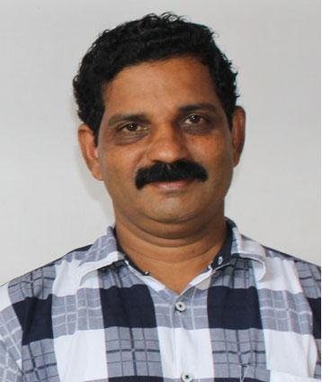
MATHEW. T 07-05-1959

29. | TGT |  | M.A B.Ed | B.Ed | 5 Years
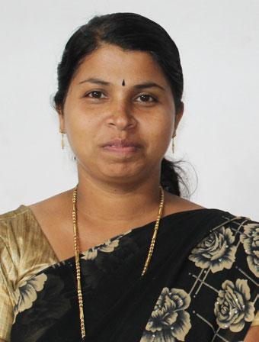
 |  | ALEYAMMA MATHEW
 |  | 06-08-1977
30. | PRT | B.A | T.T.C

ALPHONSA 07.04.1992

31. | TGT |  | MA (Ag)B.Ed | B.Ed | 5 years | CTET
 |  |  | Dip in Communicative
 |  |  | Fun: Eng
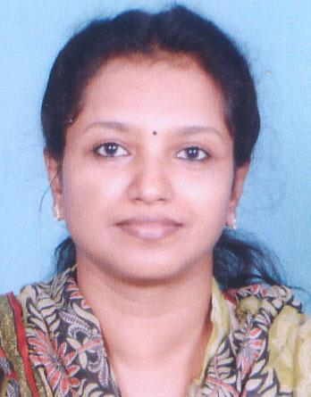
SUJA GEORGE 26-09-1968

32. | PRT |  | B.Sc B.Ed | B.Ed | 4 Years
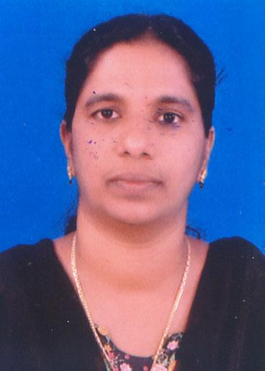
 |  | SUNITHA THOMAS
 |  | 28-05-1973
33. | PRT |  |  | B.Sc | B.Ed | 4 years
 |  |  |  | (Zoology)
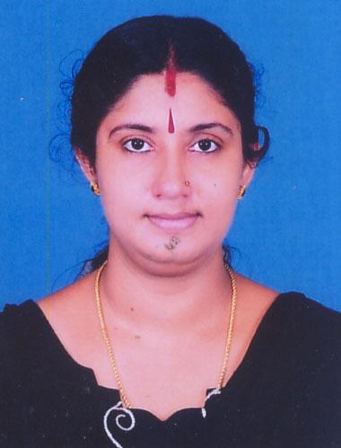
AGI CHANDRAN 29-04-1975

34. | PRT |  | B.Sc | B.Ed | 10 years | CTET Paper II
 |  |  | (Phy, Che,
 |  |  | Geology)
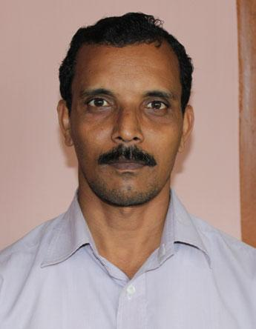
SONY MATHEW 28-05-1968

35. | PRT |  | B.A | PGDCA | 8 Years (This school)
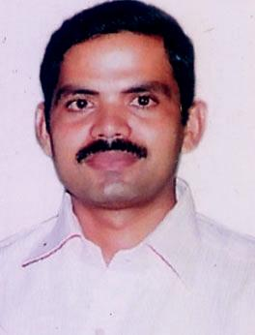
 |  | SOVICHAN MATHEW
 |  | 25-05-1975
36. | PRT |  |  | M.A (Sociology) | B.Ed | 9 years
 |  |  |  | B.Sc B.Ed
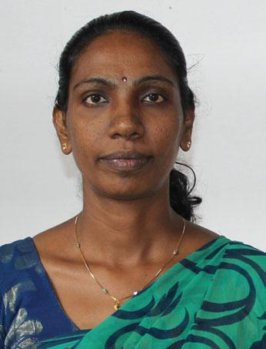
VINUTHA JACOB 28-05-1968

37. | PRT |  | M.A B.Ed | B.Ed |  | 3 Years
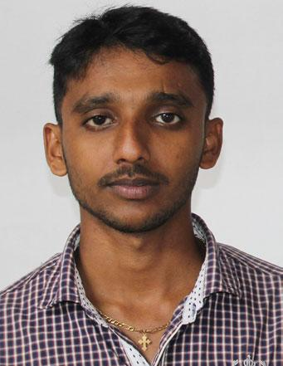
DENNY ANTONY 09-09-1988

38. | PRT |  | B.Sc B.Ed | B.Ed | 12 years
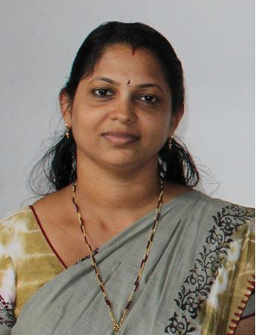
REJANI MADHU 21-12-1973

39. | PRT |  | M.A B.Ed | B.Ed | 12 years
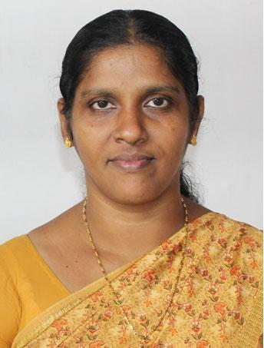
BEENA JACOB 29-05-1969

40. | PRT |  |  |  |  | B.A | B.Ed | 15 Years
 |  |  |  |  |  | Diploma in
 |  |  |  |  |  | computer
 |  |  |  |  |  | teaching school
 |  |  |  |  |  | Net Bangalore
 |  | REENA K. THOMAS
 |  | 21-11-1974
41. | TGT |  |  |  |  | Hindi Praveen | B.Ed | 11 years | 10th Supervisor
 |  |  |  |  |  | B.Ed | (Sikha Snathak) |  | 3 years
 |  |  |  |  |  | (Sikha Snathak)
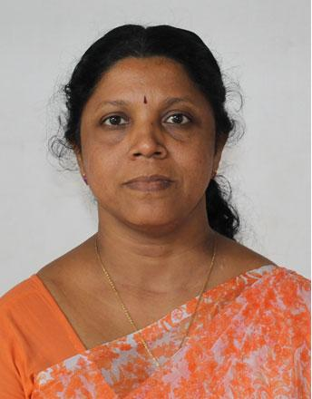
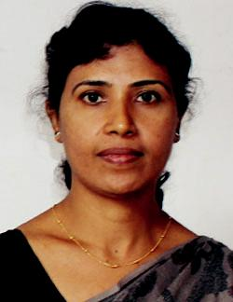
BEENA SHAJI

42. | PRT |  | B.A T.T.C | T.T.C | 7 years
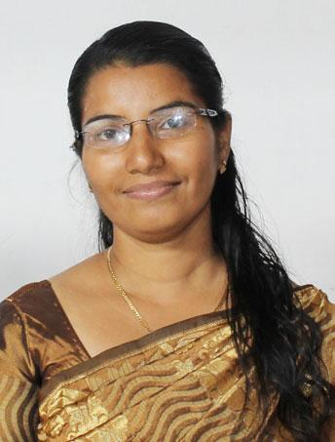
SUJA SOJAN 15-05-1975

43. | PRT |  | B.Sc B.Ed | B.Ed | 6 Years
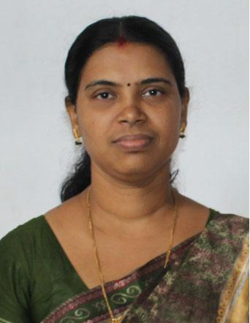
SHEELA SEBASTIAN 10-01-1975

44. | PRT |  | PDC | T.T.C | 15 years
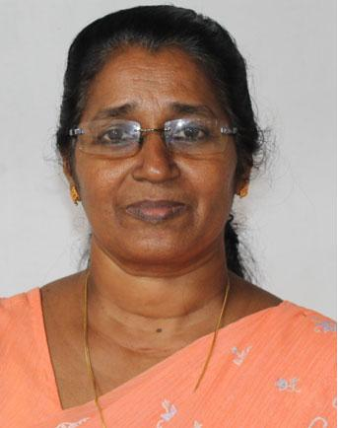
SANTHAMMA VARGHESE 25-11-1957

45. | ART |  | BFA
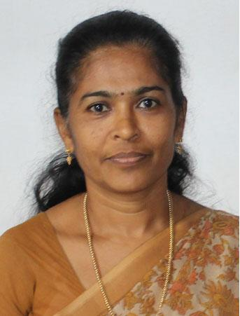
MANU MOHAN
01.02.1990

46. | P.E.T |  |  |  |  | PDC | A.R.M.Y | 5 Years
 |  |  |  |  |  |  | TRG SCHOOL
 |  |  |  | ALEX JOSEPH
 |  | 01-06-1971
47 | TGT |  |  |  |  | B.A | B.Ed | 7 Years
 |  |  | SR. LEEMA ROSE
48. |  |  |  |  |  | B.Sc B.Ed | B.Ed | 4 Years
 | PRT
 |  |  |  | JOSEY JOSEPH
 |  | 18.12.1987
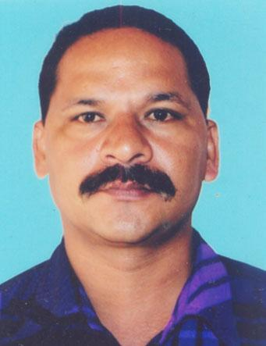
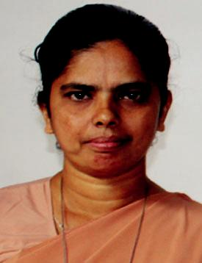
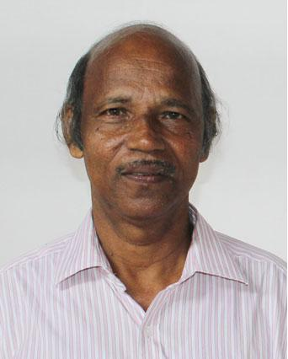

49. |  |  | M.Sc, B.Ed | B.Ed | 6 years | Attended various in service
 | TGT |  | Diploma I.P |  |  | Courses organised by
 |  |  | Diploma in Psych. |  |  | English, Language advisors,
 |  |  |  |  |  | Chief Examiner of ICSE/ISE
 |  |  |  |  |  | Exams,Evaluated ICSE
 |  |  |  |  |  | answer scripts
 | SURESH KUMAR M.B
 | 30-05-1958
50.  Guest |  |  | M.Sc |  | 7 years | Attended many orientation
 |  |  | Chemistry |  |  | and work shops
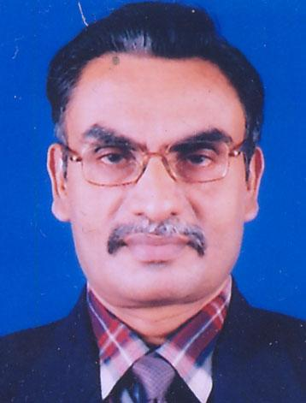
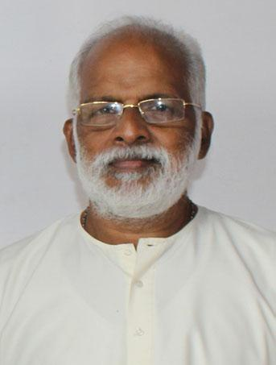
P.G MURALEEDHARAN NAIR

22-10-1947

51.  TGT |  | M.A BEd | 3 years
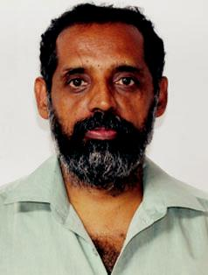
ANTONY

52 | TGT | GEETHU V  30.05.1990 | MSc | BEd | 2 Years
53 | TGT | TINTUMOL JOSEPH  03.04.1989 | MA | M Ed | 1Year
54 | PTI | JIJO MATHEW  21.03.1984 | CPEd |  | 7 Years
55 | PRT | LIBIN KURIAN  10.10.1989 | BA | B Ed
56 | PRT | JILU THOMAS  16.031992 | BSc | B Ed
57 | PRT | CICILY | BCOM | MCA | 1Year
58 | PRT | TINTUMOL MATHEW  15.05.1984 | MSc | TTC | 7 Years
59 | PRT | SR.PRASSANNA  08/11/1959 | BA | B Ed

