BASIC DETAILS
07343--SACRED HEART PUBLIC SCHOOL KILIMALA KOTTAYAM KERALA
Dated : 19/10/2016
SCHOOL NAME | SACRED HEART PUB SCH KILIMALA KOTTAYAM KL | SCHOOL CODE | 07343
ADDRESS | SACRED HEART PUBLIC SCHOOL,KILIMALA,THRICKODITHANAM P.O,CHANGANACHERRY | AFFILIATION CODE | 930341
PRINCIPAL | MR SHIJU SEBASTIAN | PRINCIPAL'S CONTACT NUMBER | 9961028485
PRINCIPAL'S EMAIL ID | fr.shijusebastian@gmail.com | PRINCIPAL'S RETIREMENT DATE | 31/03/2034
SCHOOL'S CONTACT NUMBER | 0481-2447634 | SCHOOL'S EMAIL ID | principal@shps-kili.org
SCHOOL'S WEBSITE | www.shps-kili.org | SCHOOL'S FAX NUMBER | 04812447634
LANDMARK NEAR SCHOOL | ST.XAVIER'S FORANE CHURCH THRICKODITHANAM | YEAR OF ESTABLISHMENT | 1996
AFFILIATION VALIDITY | 2001 TO 2017 | AFFILIATION STATUS | PROVISIONAL
NAME OF THE TRUST/SOCIETY/COMPANY REGISTERED WITH | THE ARCHDIOCESAN EDUCATIONAL AND CHARITABLE TRUST | REGISTRATION DATE | 11/08/1997
SOCIETY REGISTRATION NUMBER | 227/1997 | REGISTRATION VALIDITY | 06/08/2050
NOC ISSUING AUTHORITY | GOVERNMENT OF KERALA | NOC ISSUING DATE | 16/11/2000

FACULTY DETAILS
07343--SACRED HEART PUB SCH KILIMALA KOTTAYAM KL
Dated : 24/11/2016
TOTAL NUMBER OF TEACHERS (ALL CLASSES) | 59 | NUMBER OF PGTs | 11
NUMBER OF TGTs | 22 | NUMBER OF PRTs | 24
NUMBER OF PETs | 2 | OTHER NON-TEACHING STAFF | 5
NUMBER OF MANDATORY TRAINING QUALIFIED TEACHERS | 8 | NUMBER OF TRAININGS ATTENDED BY FACULTY SINCE LAST YEAR | 10

STUDENT DETAILS
07343--SACRED HEART PUB SCH KILIMALA KOTTAYAM KL
Dated : 21/10/2016
CLASS | TOTAL NUMBER OF SECTIONS | TOTAL NUMBER OF INTAKE | TOTAL NUMBER OF STUDENTS
1 | 3 |  | 120
2 | 3 |  | 118
3 | 3 |  | 117
4 | 3 |  | 119
5 | 3 |  | 120
6 | 3 |  | 120
7 | 3 |  | 118
8 | 3 |  | 119
9 | 3 |  | 119
10 | 3 |  | 108
11 | 3 |  | 105
12 | 3 |  | 91

ACADEMIC DETAILS
07343--SACRED HEART PUB SCH KILIMALA KOTTAYAM KL
Dated : 21/10/2016
SUBJECTS OFFERED FOR CLASS 10 | SUBJECTS OFFERED FOR CLASS 12
012---MALAYALAM  041---MATHEMATICS  085---HINDI COURSE-B  086---SCIENCE  087---SOCIAL SCIENCE  101---ENGLISH COMM.  531---LITERARY AND CREATIVE SKILLS  532---SCIENCE SKILLS  541---SPORTS/INDIGENOUS SPORTS  548---GARDENING/SHRAMDAAN | 030---ECONOMICS  041---MATHEMATICS  042---PHYSICS  043---CHEMISTRY  044---BIOLOGY  054---BUSINESS STUDIES  055---ACCOUNTANCY  065---INFORMATICS PRAC.  083---COMPUTER SCIENCE  301---ENGLISH CORE  500---WORK EXPERIENCE  502---PHY & HEALTH EDUCA  503---GENERAL STUDIES

INFRASTRUCTURE DETAILS
07343--SACRED HEART PUB SCH KILIMALA KOTTAYAM KL
Dated : 21/10/2016
TOTAL NUMBER OF SITES OF SCHOOL | 1 | TOTAL NUMBER OF BUILDING BLOCKS | 1
TOTAL AREA OF SCHOOL IN SQUARE METRES | 16187 | TOTAL NUMBER OF PLAYGROUNDS | 2
TOTAL AREA OF PLAYGROUND IN SQUARE METRES | 8565 | TOTAL NUMBER OF ROOMS | 70
TOTAL NUMBER OF SMALL-SIZED ROOMS | 5 | TOTAL NUMBER OF MEDIUM-SIZED ROOMS | 6
TOTAL NUMBER OF LARGE-SIZED ROOMS | 49 | TOTAL NUMBER OF MALE REST ROOM | 1
TOTAL NUMBER OF FEMALE REST ROOM | 1 | NUMBER OF GIRLS' TOILET | 35
NUMBER OF BOYS' TOILET | 35 | NUMBER OF TOILETS FOR DIFFERENTLY ABLED PERSONS | 2
NUMBER OF WASHROOMS FOR FEMALE STAFF | 2 | NUMBER OF WASHROOMS FOR MALE STAFF | 2
TOTAL NUMBER OF LIBRARIES | 1 | NUMBER OF LABORATORIES | 6
TOTAL NUMBER OF STUDENT CANTEENS | 0 | TOTAL NUMBER OF STAFF CANTEENS | 0
NUMBER OF WATER PURIFIERS/ROs | 3 | NUMBER OF AUDITORIUMS | 1
NUMBER OF LIFTS/ELEVATORS | 0 | NUMBER OF DIGITAL CLASSROOMS | 16
DOES THE SCHOOL HAS HOSTEL FACILITY | YES | DOES THE SCHOOL HAS GUARDS EMPLOYED FOR SAFETY | 1
DOES THE SCHOOL HAS FIRE EXTINGUISHERS | 12 | DOES THE SCHOOL HAS SPRINKLERS | 0
DOES THE SCHOOL HAS CCTV CAMERAS INSTALLED? |  | IS THE SCHOOL EXAMINATION CENTER OF CBSE? | NO
TOTAL NUMBER OF COMPUTERS IN ALL COMPUTER LAB | 48 | DOES THE SCHOOL HAS WEB SERVERS | 1
DOES THE SCHOOL HAS A BOUNDARY WALL? | YES | IS YOUR SCHOOL BARRIER FREE/ HAS RAMPS? | YES
DOES THE SCHOOL HAS CLINIC FACILITY? | YES | DOES THE SCHOOL HAS A STRONG ROOM? | YES
DOES THE SCHOOL HAS A GYMNASIUM? | NO | IS YOUR SCHOOL WI-FI ENABLED? | YES
PROVISION OF WEB BASED LEARNING PROGRAMS? | YES | DOES THE SCHOOL HAS FIRE ALARMS? | YES
DOES THE SCHOOL HAS SPORTS FACILITY? | YES | DOES THE SCHOOL HAS INDOOR GAMES FACILITY? | YES
DOES THE SCHOOL HAS A SWIMMING POOL? | NO | DOES THE SCHOOL HAS DANCE/MUSIC FACILITY? | YES
TOTAL NUMBER OF BUSES OWNED | 6 | TOTAL NUMBER OF BUSES HIRED | 0
TOTAL NUMBER OF VANS/MATADORS | 0 | TOTAL NUMBER OF DRIVERS | 6
NUMBER OF FEMALE ATTENDANTS FOR BUS DUTY |  | NUMBER OF ACTIVITY ROOMS | 3
NAME OF TRANSPORT COORDINATOR | FR.GEORGE VELLANICKAL | TRANSPORT COORDINATOR CONTACT | 9447269892

LOCATION DETAILS
07343--SACRED HEART PUB SCH KILIMALA KOTTAYAM KL
Dated : 21/10/2016
NEAREST NATIONALISED BANK | CANARA BANK | DISTANCE OF BANK FROM SCHOOL IN KM | 4
NEAREST BUS STATION | CHANGANACHERRY | DISTANCE OF BUS TERMINAL FROM SCHOOL IN KM | 4
NEAREST RAILWAY STATION | CHANGANACHERRY | DISTANCE OF RAILWAY STATION FROM SCHOOL IN KM | 4
NEAREST AIRPORT | KOCHI | DISTANCE OF AIRPORT FROM SCHOOL IN KM | 120
NEAREST HOSPITAL | ST.RITAS HOSPITAL | DISTANCE OF HOSPITAL FROM SCHOOL IN KM | 1
NEAREST POLICE STATION | THRICKODITHANAM | DISTANCE OF POLICE STATION FROM SCHOOL IN KM | 1
NEAREST METRO STATION |  | DISTANCE OF METRO FROM SCHOOL IN KM

OTHER VITAL INFORMATION
07343--SACRED HEART PUB SCH KILIMALA KOTTAYAM KL
Dated : 24/11/2016
10th BOARD PASS PERCENTAGE (2014/2015/2016) | 100/100/100 | 12th BOARD PASS PERCENTAGE (2014/2015/2016) | 100/100/100
NAME OF WELLNESS/ACTIVITY TEACHER | YES | NAME OF GRIEVANCE/COMPLAINT REDRESSAL OFFICER | FR GEORGE JOSEPH
CONTACT NUMBER OF GRIEVANCE/COMPLAINT REDRESSAL OFFICER | 9447269892 | EMAIL ID OF GRIEVANCE/COMPLAINT REDRESSAL OFFICER | frgeorgevellanicakal@gmail.com
NAME OF HEAD OF SEXUAL HARASSMENT COMMITTEE | MR MATHEW T AND SR VIMALA | CONTACT NUMBER OF HEAD OF SEXUAL HARASSMENT COMMITTEE | 9495913415
EMAIL ID OF HEAD OF SEXUAL HARASSMENT COMMITTEE | joerosenenim@gmail.com | NAME OF CONTACT PERSON IN CASE OF EMERGENCY | FR SHIJU SEBASTIAN
CONTACT NUMBER OF CONTACT PERSON IN CASE OF EMERGENCY | 9961028485 | EMAIL ID OF CONTACT PERSON IN CASE OF EMERGENCY | fr.shijusebastian@gmail.com
TOTAL NUMBER OF DOCTORS IN SCHOOL CLINIC | 0 | TOTAL NUMBER OF NURSES IN SCHOOL CLINIC | 0
TOTAL NUMBER OF BEDS IN SCHOOL CLINIC | 4 | LEVEL OF INVOLVEMENT OF SCHOOL IN CBSE ACTIVITIES | ACTIVE
DO THE TEACHERS GET PROPER GRADE LIKE PGT/TGT AS PER THE CLASSES THEY ARE ENTITLED TO TEACH? | YES | DO THE TEACHERS AND STAFF GET THEIR SALARY WITHIN FIRST WEEK OF THE MONTH? | YES
DOES THE SCHOOL HAS EPF FACILITY FOR STAFF | YES | EPF REGISTRATION NUMBER | KRKTM20266
MODE OF SALARY PAYMENT | bankpayment | NAME OF BANK WITH SALARY ACCOUNT | CATHOLIC SYRIAN BANK
ARE THE SCHOOL ACCOUNTS AUDITED REGULARLY? | YES | PARENT TEACHERS ASSOCIATION AS PER NORMS | YES
ACADEMIC SESSION | JUNE TO MARCH | VACATION PERIOD | APRIL TO MAY
BEST PRACTICES OF SCHOOL
The motto of our institution is Leadership,Excellence and service.The school promotes sound moral,literary and scientific education to the pupils.

PHOTO OF SCHOOL
07343--SACRED HEART PUB SCH KILIMALA KOTTAYAM KL
Dated : 20/10/2016
SCHOOL PHOTOS
GEO-TAGGED PHOTO
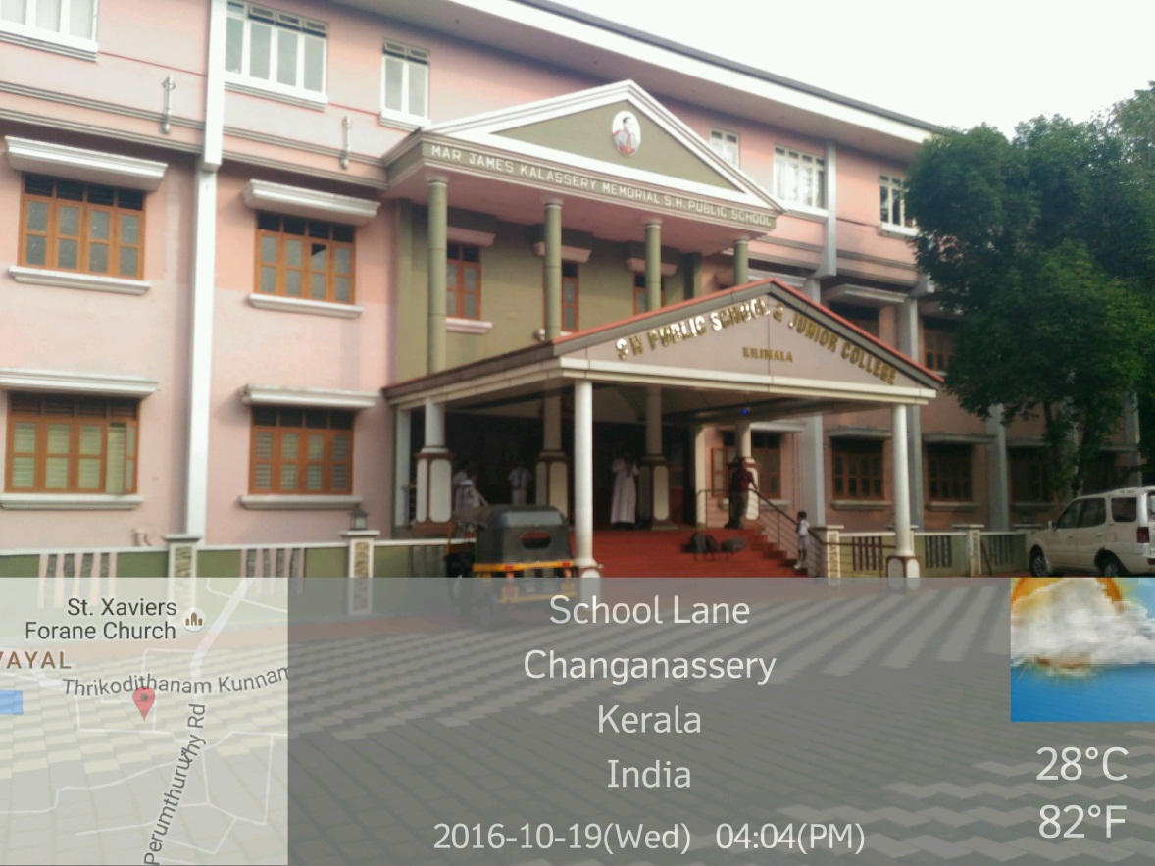
PLAYGROUND PHOTO
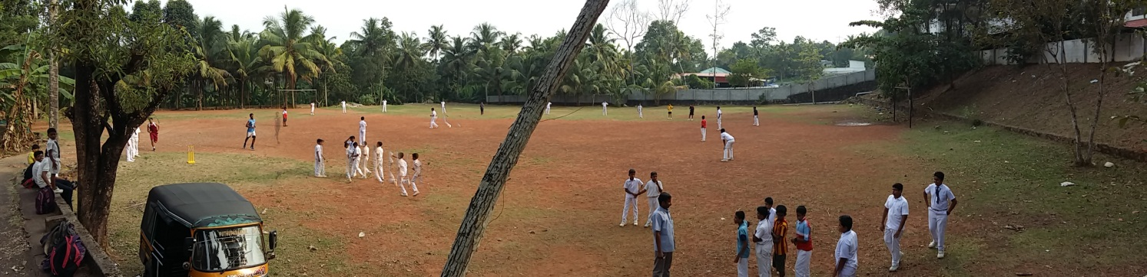
LIBRARY PHOTO
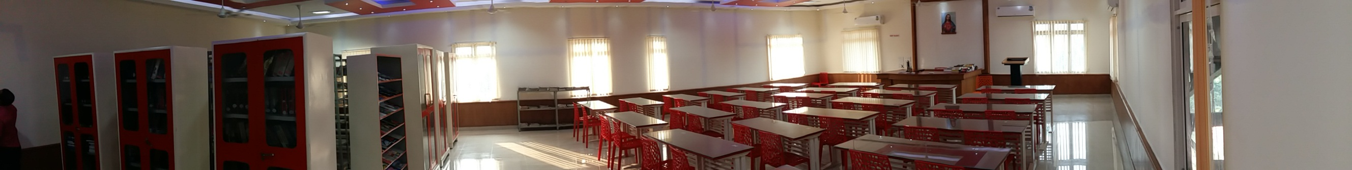
SCIENCE LAB PHOTO
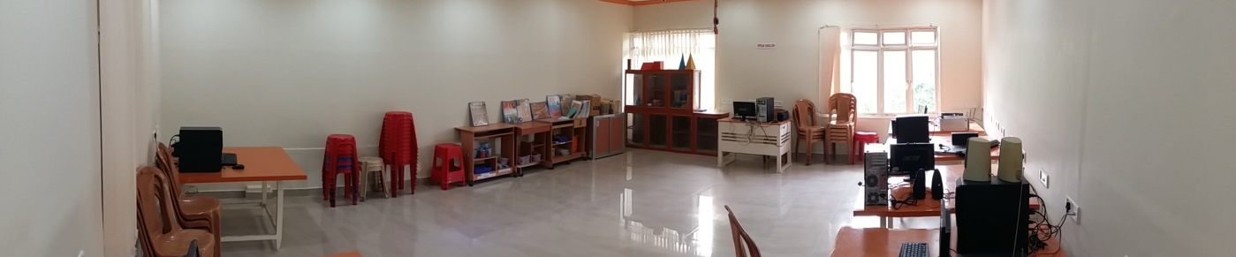
PHYSICS LAB PHOTO
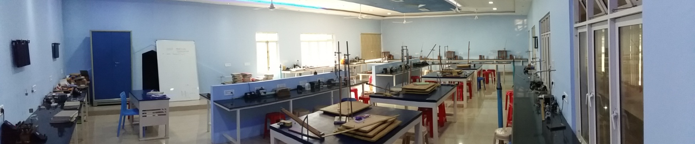
CHEMISTRY LAB PHOTO
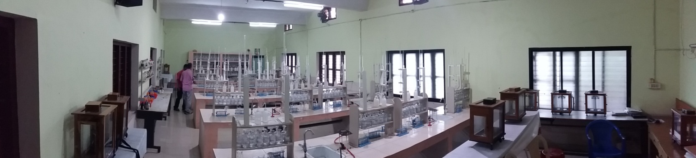
BIOLOGY LAB PHOTO
